**Question : 5B**

|  |
| --- |
| package javadbc;  import java.io.*;  import java.sql.*;  public class DeleteCol  {  public static void main(String[] args)  {  try  {  Class.forName("com.mysql.jdbc.Driver");  Connection con=DriverManager.getConnection("jdbc:mysql://localhost/it","root","");  Statement st = con.createStatement();    String table = "create table person(personid int, lastname varchar(50), firstname varchar(50), address varchar(50), city varchar(50))";  //st.executeUpdate(table);    String insert = "insert into person values(23, 'MJNV', 'Sai', 'BPM', 'VIJ')";  //st.executeUpdate(insert);    String deletecol = "alter table person drop column address";  st.executeUpdate(deletecol);    }  catch(ClassNotFoundException | SQLException e)  {  System.out.println("Some Unknown Error Occured : \n" + e);  }  }  } |

**Question : 4B**

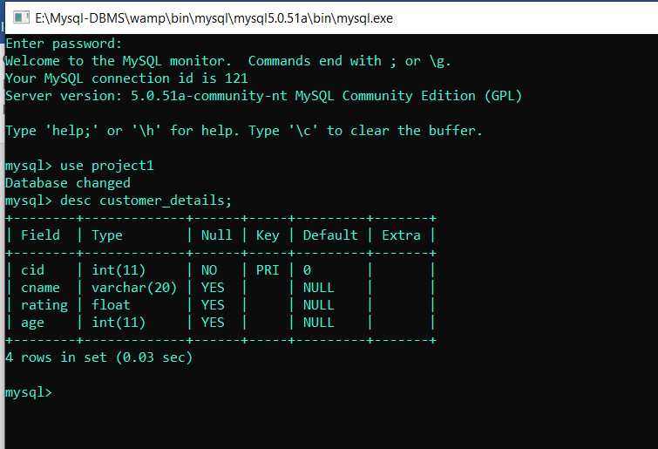

|  |
| --- |
| javadbc;  import java.io.*;  import java.sql.*;  public class SqlJoins  {  public static void main(String[] args)  {  try  {  Class.forName("com.mysql.jdbc.Driver");  Connection con=DriverManager.getConnection("jdbc:mysql://localhost/project1","root","");  Statement st = con.createStatement();    String selfjoin = "select * from customer_details t1, customer_details t2 where t2.rating < 10 and t1.cid > 10";  ResultSet rs = st.executeQuery(selfjoin);    while(rs.next())  {  int cid = rs.getInt("cid");  String cname = rs.getString("cname");  float rating = rs.getFloat("rating");  int age = rs.getInt("age");    int cid1 = rs.getInt("cid");  String cname1 = rs.getString("cname");  float rating1 = rs.getFloat("rating");  int age1 = rs.getInt("age");    System.out.println(cid + "\t\t" + cname + "\t\t" + rating + "\t\t" + age + cid1 + "\t\t" + cname1 + "\t\t" + rating1 + "\t\t" + age1);  }  }  catch(Exception e)  {  System.out.println("Some Unknown Exception Occered : \n" + e);  }  }  } |

**Question 1B**

|  |
| --- |
| package javadbc;  import java.io.*;  import java.sql.*;  public class ProductAccess  {  public static void main(String[] args)  {  try  {  Class.forName("net.ucanaccess.jdbc.UcanaccessDriver");  Connection con = DriverManager.getConnection("jdbc:ucanaccess://E:\\venkat sai\\WebDev_Program\\Products_Database.accdb");  Statement st = con.createStatement();    // Select Query  ResultSet rs = st.executeQuery("select * from Products");  while(rs.next())  {  System.out.println("Serial Number is : " + rs.getInt(2));  System.out.println("Product Number : " + rs.getInt(3));  System.out.println("Product Name : " + rs.getString(4));  System.out.println("Product price : " + rs.getInt(5));  System.out.println("Product Quantity : " + rs.getInt(6));  System.out.println();  }  }  catch(Exception e)  {  System.out.println("An Unknown Error Occured : \n" + e);  }  }  } |